

**Middle East Technical University**

**Department of Civil Engineering**

**Summer Practice Report on the Construction of the**

**"**Istanbul Grand Airport**"**

**Course Code:** CE 300 Summer Practice

**Name**: Halil Can TOPTAŞ

**Student ID:**2026540

**Date of Completion of Report:**10.10.2016

**Dates of Summer Practice:**13.06.2016-12.07.2016

**TABLE OF CONTENTS**

1.Introduction..............................................................................................................................3

2.Preface......................................................................................................................................4

3.Main Text.................................................................................................................................7

4.Interview with Supervisors....................................................................................................31

5.Conclusions............................................................................................................................32

6.References..............................................................................................................................33

**1. Introduction**

Airport's dictionary definition is a place from which aircraft operate that usually has paved runways and maintenance facilities and often serves as a terminal . An airport is an [aerodrome](https://en.wikipedia.org/wiki/Aerodrome) with facilities for flights to take off and land. Airports often have facilities to store and maintain aircraft, and a [control tower](https://en.wikipedia.org/wiki/Control_tower). An airport consists of a [landing area](https://en.wikipedia.org/wiki/Landing_area), which comprises an aerially accessible open space including at least one operationally active surface such as a [runway](https://en.wikipedia.org/wiki/Runway) for a plane to take off or a [helipad](https://en.wikipedia.org/wiki/Helipad), and often includes adjacent utility buildings such as [control towers](https://en.wikipedia.org/wiki/Control_tower), [hangars](https://en.wikipedia.org/wiki/Hangar) and [terminals](https://en.wikipedia.org/wiki/Airport_terminal). Larger airports may have [fixed-base operator services](https://en.wikipedia.org/wiki/Fixed-base_operator), [airport aprons](https://en.wikipedia.org/wiki/Airport_apron), [taxiway bridges](https://en.wikipedia.org/wiki/Taxiway_bridge), air traffic control centers, passenger facilities such as restaurants and [lounges](https://en.wikipedia.org/wiki/Airport_lounge), and [emergency services](https://en.wikipedia.org/wiki/Emergency_service).

The Istanbul New Airport (INA) will be developed by the consortium İGA through a Build, Operate and Transfer (BOT) model, in accordance with the contract with the General Directorate of State Airports Authority (DHMI). The concession contract defines four phases of development (investment) for this grand airport project.

The first phase includes a Main and Second Terminal Buildings with 88 aircraft passenger bridges, a parking area whose capacity is 12,000 car, 3 independent runways, 8 parallel taxiways,1 air traffic control tower, cargo and general aviation terminals, 3 technical blocks and other services buildings including hospitals, prayer rooms, convention centers and approximately 4,000,000 m2 of apron space. The first phase is going to complete at 2018.

The other phases includes 3 independent runways, 2 parallel taxiways, 2 terminal buildings and apron area. Whole project will be finished at 2030.

Istanbul has two airports named as Ataturk and Sabiha Gökçen. Sabiha Gökçen International Airport was built on Anatolian side and Ataturk Airport was built on European Side. Ataturk Airport's area is incapable of cost effective expansion to meet increasing demand. Here is no space to build an additional runway on the Ataturk site, as the airport is

within the city of Istanbul. Industrial areas are situated north of the airport, with residential areas to the west and east of it. Because of the limited capacity, the Turkish Airspace Authority does not allow additional cargo or charter flights to the airport.

**3**

The new airport is constructed at the intersection of junction roads of [Arnavutköy](https://en.wikipedia.org/wiki/Arnavutk%C3%B6y,_%C4%B0stanbul), Göktürk and [Çatalca](https://en.wikipedia.org/wiki/%C3%87atalca), north of European side of Istanbul between the [Black Sea](https://en.wikipedia.org/wiki/Black_Sea) regions of Tayakadın and Akpınar. 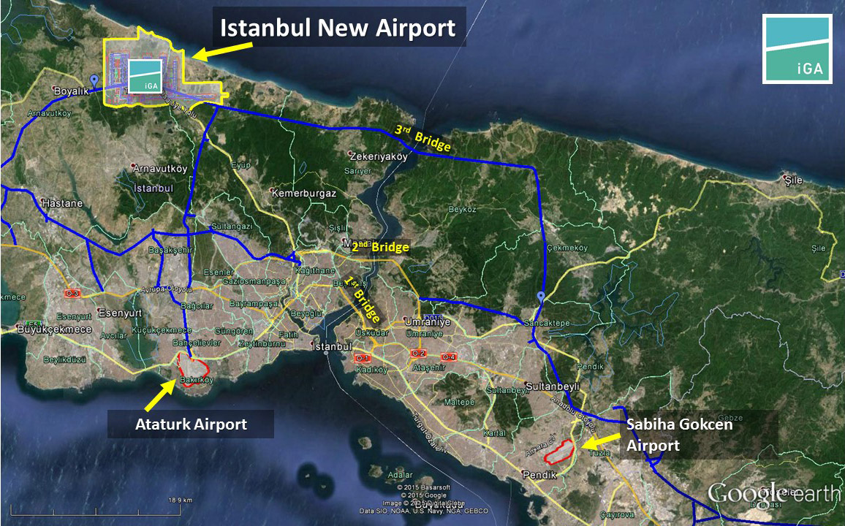

**Figure 1 - Locations of Airports in İstanbul**

The airport is planned as the largest airport in the world with a 200 million passenger annual capacity. [Istanbul Ataturk Airport](https://en.wikipedia.org/wiki/Istanbul_Atat%C3%BCrk_Airport) will be closed down once the new airport is operational.

**2. PREFACE**

The İGA journey started on May 3, 2013 when DHMI (General Directorate of State Airports Authority of Turkey) awarded the contract for construction and operation of Istanbul New Airport to the Cengiz -MAPA- Limak- Kolin- Kalyon Consortium. the consortium founded a new company under the name "İGA" on October 7, 2013. İGA will continue to improve and operate Istanbul New Airport for 25 years.

**4**

The construction site is very huge, so the area includes every part of company. The main campus, construction sites, medical center, factories, accommodations, cafeterias, gas stations etc. Construction sites sectioned as their functions such as Terminal Buildings, Piers, Parking Areas, Runways etc. When counting sub-contracted employees, approximately a total of 18 thousand persons work on the site. 1.500 white-collar employees including managers and engineers. Total 822 high-capacity machines and 2200 high-tonnage trucks well designed are using for construction.

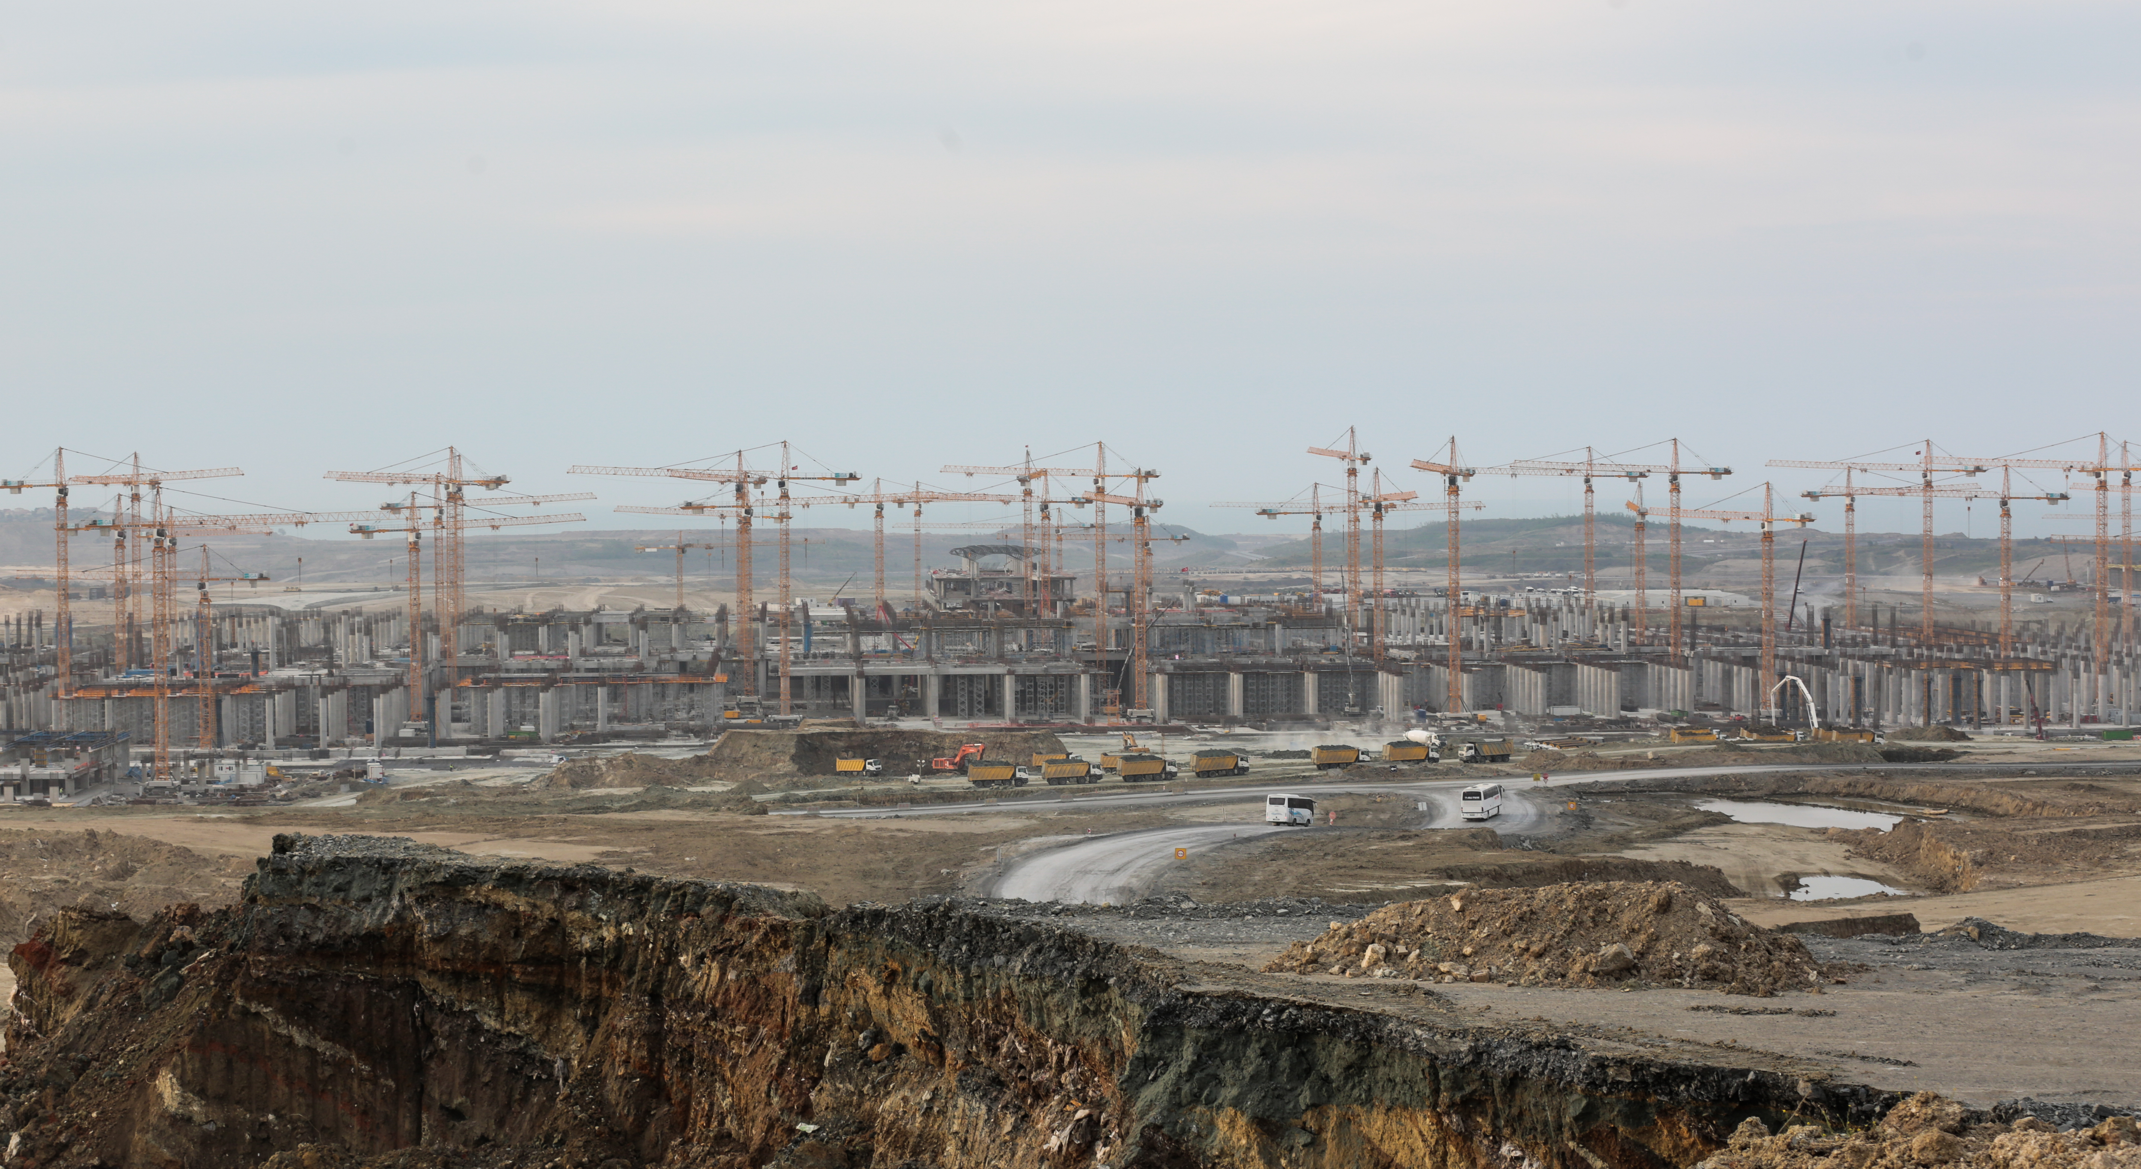

**Figure 2 - Construction of Terminal Building**

There are some positive sides of working in İGA. Firstly, the number of engineers is much, so different experiences can be shared. Different types of work can be observed, from substructure works to infrastructure. Every person who worked with İGA can develop his/her knowledge.

**5**

The squad of Terminal Building 1 is listed below :

Project Manager: Mustafa Bayraktar

Site Manager: Mustafa Kılıç

Trim Works Chief: Tamer Çelik Technical Office Chief: Taner Keskin

Rough Work Chief: Yasin Günek

Site Engineers: Levent Gülmüş, Nazmi Mert Uğurtürk, Mehmet Süreyya Ulusan, Öner Hazar, Osman Kürşat Altıntaş, Esat Keklik

Technical Office Engineer: Songül Aksoy

Construction Technicians: Sadık Doğanay,Ayhan Kemal Özüpek,Murat Alagöz

Technical Office Technicians Duygu Tuncer, Deniz Sinem Çalasın

Whole Terminal Building 1 office's people helped to my intern days to learn more. It is very nice to meet them.

**6**

**3. MAIN TEXT**

**Week 1**

**SUMMARY FORM**

|  |  |
| --- | --- |
| Date :13.06.2016 | .............1............. working date |
| Summary of the Work Done:  ...................................................................................................................................................  In my first day, after finishing my personal paperwork in main campus of IGA , I got examined in hospital which located in Akpınar campus. Later on, I attended Occupational Health and Safety Training and Working on High Level Training.    These trainings include things to take into consideration during internship, usage of OHS equipment, if emergency case happen where I will get help and while working on high level, how I can provide security for myself and for other workers. These trainings and final exams last approximately 4 hours. One OHS expert, one Lifeline expert and one First Aider give these  Finally, I and other interns returned to main campus. We got IDs, hardhats, vests and shoes with steel toecap. After registered for shuttle, my first internship day is over.  ................................................................................................................................................... | |

Stamp

Name, Surname, Signature of the Supervisor:

**7**

**SUMMARY FORM**

|  |  |
| --- | --- |
| Date :14.06.2016 | ............2.............. working date |
| Summary of the Work Done:  ...................................................................................................................................................  In second day, I met with Levent Gülmüş as a department chief and Musa Erdem Mecit as a one of the site engineers. During my internship, I will work with them. They informed me about whole project and process. In worksite, while rough construction is going on, trim works has started in some regions. In rough construction sites, beams have given priority. Also BHS(Baggage Handling System) regions have priority in trim works. Roof system installation has started in Piers.  ...................................................................................................................................................  ................................................................................................................................................... | |

Stamp

Name, Surname, Signature of the Supervisor:

**8**

**SUMMARY FORM**

|  |  |
| --- | --- |
| Date :15.06.2016 | .............3............. working date |
| Summary of the Work Done:  ...................................................................................................................................................  Engineers responsible from interns have made plan for us. They want interns observe different constructions in each week. In first week, I and 2 other intern will observe columns. Some of these columns' groundwork finished 2 months ago and some of them is digging. So I had a chance to observe every single stage of column construction.  ...................................................................................................................................................  .................................................................................................................................................. | |

Stamp

Name, Surname, Signature of the Supervisor:

**9**

**SUMMARY FORM**

|  |  |
| --- | --- |
| Date :16.06.2016 | ............4.............. working date |
| Summary of the Work Done:  ..................................................................................................................................................  Today, I traveled the area and observed columns. There are square columns in shear walls, these are in two different sizes, 2x2 meters and 2x2,17 meters.  The other column type is circular column. Circular columns have also two types. At main axis, circular columns have 2 meter diameter and at other axis, they have 1.5 meter diameter.  ..................................................................................................................................................... | |

Stamp

Name, Surname, Signature of the Supervisor:

**10**

**SUMMARY FORM**

|  |  |
| --- | --- |
| Date :17.06.2016 | .............5............. working date |
| Summary of the Work Done:  ...................................................................................................................................................  ...................................................................................................................................................  3 points are observed while pouring of concrete;  -Slump value of concrete  -True usage of vibrator  -Located form in own axis  First and second points are about concrete. If there is a small error, segregation will be observed. This situation will affect concrete's quality. Last point is about adaptation of architecture and rough construction.  ................................................................................................................................................... | |

Stamp

Name, Surname, Signature of the Supervisor:

**11**

**SUMMARY FORM**

|  |  |
| --- | --- |
| Date :18.06.2016 | ............6.............. working date |
| Summary of the Work Done:  Before concrete pour in columns, some procedures and submittals are applied.  I and relevant site engineer checked these procedures. Musa Chief gave the responsibility of control for next 2 days. Because daily (average) 18 column are completed, there is no chance to make a mistake. So, if there is a problem, making a contact with subcontractor's team is wanted from me.  ................................................................................................................................................... | |

Stamp

Name, Surname, Signature of the Supervisor:

**Discussion**

* A baggage handling system (BHS) is a type of [conveyor](https://en.wikipedia.org/wiki/Conveyor_belt) system installed in [airports](https://en.wikipedia.org/wiki/Airport) that transports checked [luggage](https://en.wikipedia.org/wiki/Luggage) from ticket counters to areas where the bags can be loaded onto [airplanes](https://en.wikipedia.org/wiki/Airplane)

**12**

* 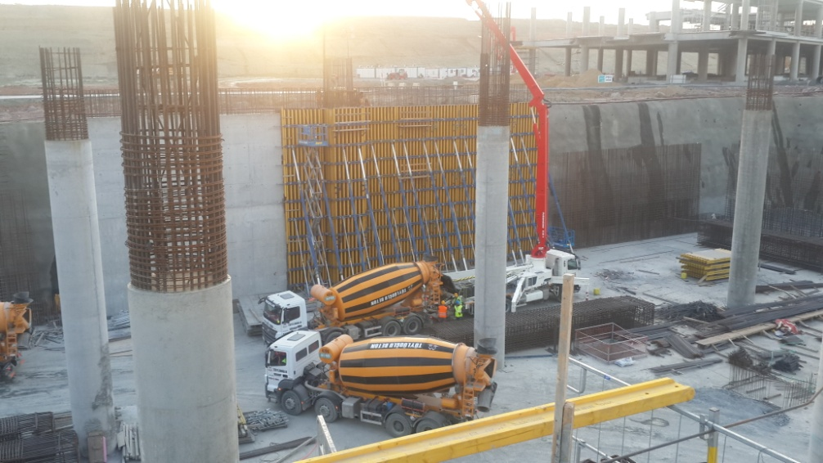Square columns reinforcements are 17 ton. These reinforcements are connecting on benches then install their places via tower-cranes. After that, patternmakers close their forms and pour their concretes. For square columns, panel forms are using.

**Figure 3 - Square Columns in Shearwall**

* 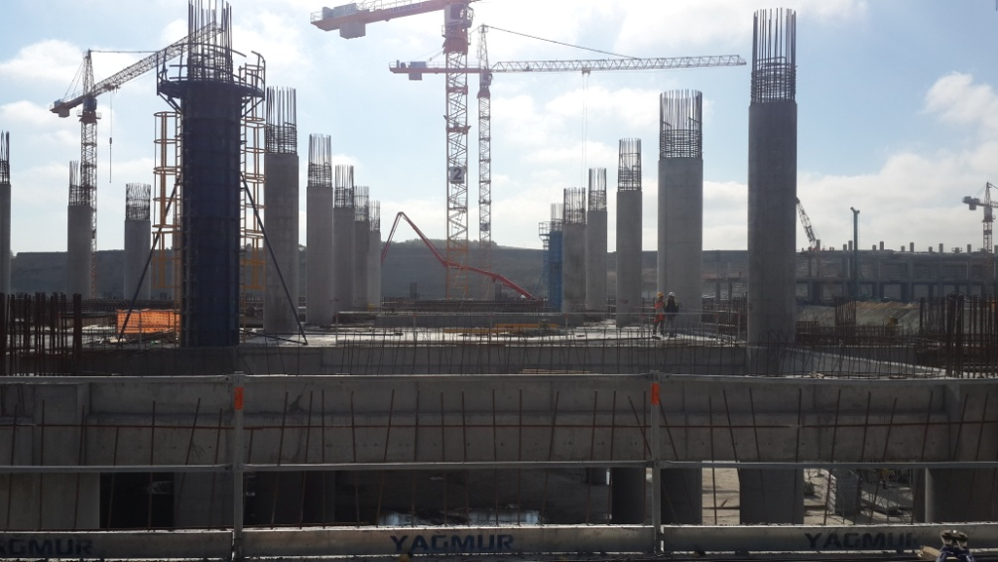They include approximately 7,5 ton reinforcement in every circular column. Their forms made of 2 steel pieces.

**Figure 4 - Circular Columns**

**13**

* Briefly procedures and submittals listed below;

1. -Suitability of columns which are built and installed its place by subcontractor for project
2. -Distance between axial points and columns' places
3. -Joints which have rebar from below are checked by site team's of the İGA.
4. -Discussed with electrical and mechanical departments and get information about earth and installment. If necessary installment or earth is exist, production is going to start.
5. -Forms are closed by workers after QCT (Quality Control Team) has taken that product.
6. -When form works are finished, Survey Team has started to check column from above and below points. In column products, error margin is 2 millimeter per meter
7. After confirmation from all departments, concrete pouring process is started.

**WEEK 2**

**SUMMARY FORM**

|  |  |
| --- | --- |
| Date :20.06.2016 | .............7............. working date |
| Summary of the Work Done:  ...................................................................................................................................................  Today, workers has started installment Dead Formwork system(Kör Kalıp Sistemi) for 800 meter square area. Foremen built a new team for this big area. The team has 20 pattern-makers. Installation of Dead Formwork system is easy so a pattern-maker can finish 40 meter square area.  Before the end of day, 800 meter square area be floored with Dead Formwork system. While installment, gaps are filled with XPS or scum because concrete should not pass below part.  ................................................................................................................................................... | |

Stamp

Name, Surname, Signature of the Supervisor:

**14**

**SUMMARY FORM**

|  |  |
| --- | --- |
| Date : 21.06.2016 | ..............8............ working date |
| Summary of the Work Done:  ..................................................................................................................................................  Foot's which made of PVC are placed in forms. They are fixed on Slab on Grade (SOG) part as perpendicular to floor. In each forms, reinforcement being taken into PVC tubes. Reinforcement mesh with 188x188 is placed on them. Concrete which is inside of PVC gets structural bearing feature and concrete which covers mesh can transfer loading to this structural bearing component.    Reinforcement mesh installed as a upper part and below part. Weatherboards of reinforcement mesh's are arranged as three niches.  ...................................................................................................................................................  ................................................................................................................................................... | |

Stamp

Name, Surname, Signature of the Supervisor:

**15**

**SUMMARY FORM**

|  |  |
| --- | --- |
| Date : 22.06.2016 | .............9............. working date |
| Summary of the Work Done:  Today, Baggage Handling System area whose pattern-work had done on Monday and steel work had done on Tuesday is ready for pouring work. There is a specific team has come for this work because Baggage Handling System area is very important and critical. This team does only terminal building area's pouring work.  Pouring upper elevation is -12,40 and this is finished pavement elevation. Error margin is 2 millimeter so they work with laser nivo.  C35 exposed concrete is used. When slump value of this concrete decreases below 25, it is returned to factory. Slump value of concrete is very important for the concrete settling in PVC tubes.  Vibrators are not used in this area because Dead Formwork system is very sensitive. They are placing concrete with rodding PVC tubes.  ................................................................................................................................................. | |

Stamp

Name, Surname, Signature of the Supervisor:

**16**

**SUMMARY FORM**

|  |  |
| --- | --- |
| Date : 23.06.2016 | ............10.............. working date |
| Summary of the Work Done:  ...................................................................................................................................................  I had a contact with subcontractors' engineers that work in TB1(Terminal Building 1) area after breakfast. I got information about daily planning. They tell that columns will be finished when and in which area. Today columns numbered as C1245,C1246, C1183, C1222, C1371, C1126, C1374, C1188 are prepared. Earth line is installed on C1245 and C1126. There are 8 columns are completed while I was a related controller. Other columns will be poured at night shift.    ...................................................................................................................................................  ................................................................................................................................................... | |

Stamp

Name, Surname, Signature of the Supervisor:

**17**

**SUMMARY FORM**

|  |  |
| --- | --- |
| Date : 24.06.2016 | .............11............. working date |
| Summary of the Work Done:  ...................................................................................................................................................  I gave a report that columns were poured yesterday to my chiefs this morning.  I delivered 3 columns before noon and pouring of concrete started immediately. However, tower cranes had to stop because of speed of wind after noon. The form work on columns finished at night shift because closing form on columns is impossible without tower cranes.  ...................................................................................................................................................  .................................................................................................................................................. | |

Stamp

Name, Surname, Signature of the Supervisor:

**18**

**SUMMARY FORM**

|  |  |
| --- | --- |
| Date : 25.06.2016 | .............12............ working date |
| Summary of the Work Done:  ...................................................................................................................................................  Today we went to TB1-4 area which includes BHS(Baggage Handling System) in order to observe installment of SOG(Slab on Grade) pavement. Baggage Handling System's area is nearly 130800 meter square.  ...................................................................................................................................................  ................................................................................................................................................... | |

Stamp

Name, Surname, Signature of the Supervisor:

**19**

**Discussion**

* 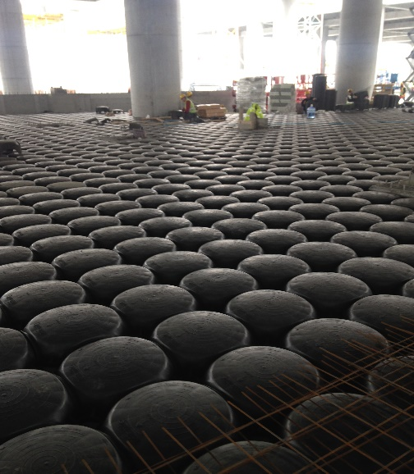Dead Formwork System is used for SOG pavement. Although this system increases the cost, the owners separate extra money for this installment because Dead Formwork is more practicable than sanding. Also installment of Dead Formwork is faster than sanding. So Dead Formwork is attractive choice for engineers and owners. They bought Dead Formwork from Italy.

**Figure 5 - Blank Mould System**

**20**

* C1245,C1246, C1183, C1222, C1371, C1126, C1374, C1188 are in two sizes. Six columns have 1.5 meter diameter and other two columns have 2 meter diameter. Two meter diameter column takes 24 cubic meter concrete and one point five meter diameter column takes 14 cubic meter concrete. Columns which starts from foundation take 32 cubic meter concrete.
* Every day, site workers gave a report which includes yesterdays' production to technician office. Technician office reports this progression all related employee. After analyzing these reports, the direction and speed of construction is replanned, if necessary.
* When speed of wind is 50km/h or much, tower cranes have to stop. If they don't stop working, any accident will be happened.In this construction site, tower cranes are full of electronic circuits .They use the Litronik Technology. If tower cranes do not work, the daily program of construction are delayed and this is very unexpected event for this project .
* Totally 58 tower cranes are working on terminal building and in every area there is 2 tower cranes. One of them is installed for stable work and other is installed for not stable work. They can handle materials on every point of construction site.

**21**

**WEEK 3**

**SUMMARY FORM**

|  |  |
| --- | --- |
| Date :27.06.2016 | .............13............. working date |
| Summary of the Work Done:  ...................................................................................................................................................  This week will be about beams, I will observe process of installation and placement of it.  Beam's production process is starting with placing formwork with table module. Formwork with table modules which montaged before are taking place between related columns. Head of columns are closing with plywoods. A room is prepared averagely one day with 1 land surveyor, 1 chainman and 14 pattern-makers.  This work is extremely dangerous, so tower-cranes stop when wind is going faster.  Doka's Formwork with Table Module (Masa Kalıp Sistemi) are using.  ................................................................................................................................................. | |

Stamp

Name, Surname, Signature of the Supervisor:

**22**

**SUMMARY FORM**

|  |  |
| --- | --- |
| Date : 28.06.2016 | .............14............ working date |
| Summary of the Work Done:  ...................................................................................................................................................  Today, one area's formworks with table module have prepared for the beam reinforcement's production. 2 Survey Team and 38 pattern-makers worked in this area.  After placing formworks with table module, survey team marked points which beams start and end points. Then, survey team left this area.  Beams which prepared on bench are placing with the help of tower-cranes in this area whose points are marked and formwork with table module are prepared. The workers connected main & secondary beams to columns head.  Because of fitting precasts, gusset is cut. Beams which prepared on benches are like reverse 'T' letter. Gusset is not a part of secondary beams.  ................................................................................................................................................. | |

Stamp

Name, Surname, Signature of the Supervisor:

**23**

**SUMMARY FORM**

|  |  |
| --- | --- |
| Date : 29.06.2016 | .............15............. working date |
| Summary of the Work Done:  ...................................................................................................................................................  Today, connecting column heads which did not finish yesterday is going on. 3 ironforger is working on each column head. This is because of effectiveness. Worker's areas are narrow so 4 iron forger do not work same time. While connecting beam production was going during day, also 2x2 meter square reinforcement's area is connected. This made it easy when column production goes upper level. Moreover, when concrete topping floor pours on precasts, there will be a hole under concrete and this will not be cause any architectural problem.  All column heads are prepared. First, İGA's related cite engineers checked production. Then İGA's Quality Control Team checked with project on paper. There was not a problem so there was not a delay on schedule.  Today's last job was reporting every reinforcement that ready for concrete pouring to pattern-maker in order to start closing forms tomorrow.  ................................................................................................................................................... | |

Stamp

Name, Surname, Signature of the Supervisor

**24**

**SUMMARY FORM**

|  |  |
| --- | --- |
| Date : 30.06.2016 | ............16.............. working date |
| Summary of the Work Done:  ..................................................................................................................................................    Forms which prepared before and cut according to gusset are montaged and fixed with tie-rods. After all work finished, survey team is invited this area in order to checking procedure. Survey team checked total 18 point which beams start and end points. Their error margin is 4 millimeter for this area.  After Survey Team's checking procedure, concrete was ordered. C35 exposed concrete with 22 slump value was pouring sensitively while vibrator was working. Pouring process was very slow because distortion is not a wanted result.  ..................................................................................................................................................  ................................................................................................................................................... | |

Stamp

Name, Surname, Signature of the Supervisor:

**25**

**SUMMARY FORM**

|  |  |
| --- | --- |
| Date : 01.07.2016 | .............17............. working date |
| Summary of the Work Done:  ...................................................................................................................................................  Beams whose pouring process was over, side forms are raveled out after 12 hours. After 7 days, formworks with table module which laying under beam are taken out.  Later on, precasts which produced before are placing these rooms carefully. Elastomeric supports are attached to where precasts press on gusset. After precasts become whole, cords was placed in gaps. Reinforcement meshes were placing for concrete topping floor.  Completing precasts for one room take 135 minutes. Averagely 10 precast components are using for one room. This prestressed precast components are produced in factory with C50 concrete. There is a reverse deflection at middle parts.  .................................................................................................................................................. | |

Stamp

Name, Surname, Signature of the Supervisor:

**26**

**SUMMARY FORM**

|  |  |
| --- | --- |
| Date : 02.07.2016 | .............18............ working date |
| Summary of the Work Done:  ...................................................................................................................................................    Precast program which will be used in whole day and during night shift is created. Total 7 room's precast components are completed at 0,00 , +8,00 and +15,00 elevation. They are ready for the pouring concrete topping floor.  Beams whose have in-situ concrete slabs need more forms and more workmanship. Although it causes lost of productivity, some areas have in-situ concrete slabs because of overloading. In-situ concrete slab parts are supported also with cantilever beams.  ...................................................................................................................................................  ................................................................................................................................................... | |

Stamp

Name, Surname, Signature of the Supervisor:

**27**

**Discussion**

* Beam's reinforcements are dense at top and bottom parts. This is because support part is about shearing and body part is about pressure.
* Only 3 ironforger is working on each column head because of effectiveness. Worker's areas are narrow so 4 iron forger do not work same time.
* Every reinforcement, their number and placement, weatherboard spaces, distance pieces and lateral reinforcement binders, concrete cover distances are checked carefully before concrete pouring.
* A pattern-maker can complete approximately 6 meter square area's form-work alone. A room includes 2 main and 2 secondary beams and these are equal 52 linear meters. So, this means in order to close forms in one day, 30 pattern-makers needed. This calculation is valid for beams which precasts are put on them. Work force calculation is different for the in-situ concrete slabs.
* Beam's Cold Joint Points are at next beam's L/4 (L is length of beam). This point is on where shear force equal zero so they are very careful about this point.
* Organization of precast work has a different difficulty. Timing, ordering, placing of precasts could not be wrong. Precast components are special for their areas. They are getting from factory to area with trucks and tower-cranes are putting and transferring them to related places.

**28**

**WEEK 4**

**SUMMARY FORM**

|  |  |
| --- | --- |
| Date :11.07.2016 | .............19............. working date |
| Summary of the Work Done:  ...................................................................................................................................................  Today, I observed trim work at Pier 1's construction site. The area which includes the gate numbered as F64 is preparing as mock-up area. In this area,  -Interior wall veneering  -Roof veneering  -Ceramic surfaces  -Moving walkways and carpet covered surfaces are getting ready.    This workload is because statesmen will visit construction site, so many workers, architectures and engineers take their attention in order to complete mock-up building.  ................................................................................................................................................... | |

Stamp

Name, Surname, Signature of the Supervisor:

**29**

**SUMMARY FORM**

|  |  |
| --- | --- |
| Date : 12.07.2016 | ..............20............ working date |
| Summary of the Work Done:  ...................................................................................................................................................  Today, I observed that how NFI forms are preparing and how they are publishing. Site engineers have to do these when even a single production is finished  I compared the old project with revised project with my chief. I controlled and reported that there is not a difference in this area to my chief. He informed related departments. After noon, the rooms whose precast components must be installed urgently are detected and reported. I went to main campus of İGA and my quitting works were completed by HR. The Head of HR signed my documents, then I gave back my ID, hardhat, vest and shoes with steel toecap . I returned to office to be signed my reports. Project Manager and my chief signed necessary parts.  ................................................................................................................................................... | |

Stamp

Name, Surname, Signature of the Supervisor:

**Discussion**

NFI is abbreviation of Notification for Inspection. The all departments can be informed with these forms. Related departments' engineers come and check related productions. If there is not any problem, concrete pouring starts. I am tasked with preparing and publishing NFI's.

**30**

**4.INTERVİEW WITH SUPERVISOR**

Musa Erdem Mecit is one of the site engineers in the Terminal Building 1's project. 29-year-old chief has graduated from Istanbul Technical University's Civil Engineering department. He has started to work with İGA for 5 months.

Firstly, I asked his experiences ,

" I finished my license program in 2009. In those days, I thought that working in foreign countries is the only way for a new-graduated engineer. I contacted with different companies; However. some of them did not return my applications, the others offered very poor conditions. So I changed my mind and I searched a job in İstanbul. I got a big hotel project in Karaköy-İstanbul. It took 9 months. I did not experience much rough works but a lot of trim work I had experienced. After that, I founded my own company. It was really difficult days because founding new company, running, finding appropriate projects were not easy as said. Finding new projects were getting harder day by day. Finally, with two general elections in Türkiye, I had to abandon my company. Then, I decided that I returned to university and worked on my dissertation about 'Insulator Systems on Buildings'. 1 Week before the exam, İGA contacted with me. They told that they will use insulator system so they offered to job. I accepted that and now here I am."

Secondly, I asked his opinions about this project.

" Airports in İstanbul are not sufficient especially last 3-5 years. Every flight delay before departure and tour on sea before landing. So, a big airport for İstanbul is vital requirement. With this project, we are building the biggest airport in the world. Construction sites are very huge, opportunities are like endless. Different kind of systems are being used. For example, blank mould systems are being used greatly. This system is not very common for constructions. High-class materials are being used in every part. With these opportunities, every worker can get different experiences. After all, working conditions are really difficult. We are working at 7 days of a week between 07:30-19:30. We have one off day at the end of 14 days, so it is not a easy job working here but also it develops our knowledge about engineering.

**31**

**5.Conclusion**

Summer practice is a chance to start to be real engineer. During a year, students are learning theoretical topics. Theoretical basis of course essential but without practice, students will not be learn something's' workableness. Internship days are beginning of engineering.

At the end of spring semester, I did not know to much thing about construction sites, machines, reading projects etc. I did not know any Turkish expression about structures. It was the first time I was on construction site. I tried to learn as much as I saw. My older intern friends and our engineers helped at the beginning of days. Later on, I spoke with foremen. Someday, I performed speech with workers. They learnt to me details of their jobs. Someday, I helped to them. Day by day I learnt basis of constructions.

At the same time, when I was in technical office because of air conditions, office technicians tried to show how projects are reading, how quantities are performing etc. They wanted from me some drawings on AutoCAD when I was free.

I witnessed the management side of construction,also. Timing is very important for construction. Everyone were working with schedule. If one of them skips his/her work, whole schedule will go wrong. Organization is important, managing the organization is more important than. So, also office work is not easy for civil engineers.

In conclusion, summer practice is the important step for being an engineer. Two obligatory internship is a good chance; However, 20 work days are not enough to learn basis of works. Duration must be stretched out. Both site and office practices must be extended to 40 work days.

**32**

**6. REFERENCES**

* http://www.igairport.com/en/istanbul-new-airport/construction/about-the-construction
* http://www.merriam-webster.com/dictionary/airport
* https://en.wikipedia.org/wiki/Baggage_handling_system
* https://en.wikipedia.org/wiki/Istanbul_New_Airport

**33**